AE 721

Aerospace Design I Laboratory: Missile Design

Course Outline and Requirements Fall 2023

1. General Items
1.1. Class Times & Conditions:
- Class times: 1 - 1:50pm M/W, -2:50F G400 LEEP2/1182 Learned Hall
- Special virtual class gatherings may be called
- Note Air Armament Symposium field trip November 6 - 10, 2023
- Class website: https://www.aerodoc.tech/721

1.2. Instructor: Dr. Ron Barrett-Gonzalez
adaptivebarrett@gmail.com, (785) 760-4614 (cell) 856-9969 (home)
Physical Office Hours: 2 - 4pm 1182 Learned Hall

Note that many days collisions with other meetings are bound to occur. Just get in touch with Dr. Barrett via e-mail or phone if that happens. If a review of notes is needed, a quick Zoom conference can often clear things up. So be at a terminal which can handle a quick conference (sound card, good screen etc.). Feel free to call Dr. Barrett during waking hours. Bedtime is generally around 11pm. If he can answer, he will answer. He generally switches from cell phone to land line after dinner.

1.3. This Document Subject to Change! Check https://www.aerodoc.tech daily for updates.

1.4. Textbook & References: Students are asked to purchase “Missile Design and System Engineering,” by Eugene L. Fleeman, 2022.

https://arc.aiaa.org/doi/book/10.2514/4.869082

1.5. Attendance:
Attendance is not required. However, given that quizzes will be administered during class time, missing a class means missing a quiz.

1.6. Disabilities & Inclusion: KU strictly observes the Americans with Disability act as well as principles of ethics, diversity and inclusion and takes these matters seriously.

From KU’s Diversity and Inclusion Statement http://policy.ku.edu/provost/diversity-inclusion

“As a premier international research university, the University of Kansas is committed to an open, diverse and inclusive learning and working environment that nurtures the growth and development of all. KU holds steadfast in the belief that an array of values, interests, experiences, and intellectual and cultural viewpoints enrich learning and our workplace. The promotion of and support for a diverse and inclusive community of mutual respect require the engagement of the entire university. The University of Kansas prohibits discrimination on the basis of race, color, ethnicity, religion, sex, national origin, age, ancestry, disability, status as a veteran, sexual orientation, marital status, parental status, gender identity, gender expression and genetic information in the University's programs and activities.”

Let Dr. Barrett know what name you prefer him to call you and if you are comfortable, what pronouns you prefer. Let Dr. Barrett know, privately or thorough proper KU channels if you need an accommodation of any kind.

1.7. Emergencies: Dial 911

1.8. Special Considerations Relating to COVID-19 and other pathogens: Follow CDC guidelines.

1.9. Quizzes: Regularly administered in class or with accommodation. As per the directives of the KU Student Access Center, no quizzes or tests can be administered for the remaining duration of the class.

1.10. Reports: Students may not copy sections from other or past reports or others' work(s) without explicit written authorization by Dr. Barrett. Plagiarism will be handled as Academic Misconduct and may lead to sanction up to expulsion. Reports are due on Mondays by 8pm Central Time and turned in to:
kuaerodesign@gmail.com
All work this semester must be the product of the individual student. Unauthorized aid given or received between students will be treated as academic misconduct.

Reports must be named as follows:
AE721_Report#_Teamname.doc example: AE721_Report1_MissileZappers.doc
AE721_Report#_Teamname.pdf example: AE721_Report1_MissileZappers.pdf
AE721_Report#_Individual’s Last Name.doc example: AE721_Report1_Barrett.doc
AE721_Report#_ Individual’s Last Name.pdf example: AE721_Report1_Barrett.pdf

Students must submit their original .doc file (or file from the package that generated the document) along with a .pdf version of the report. The .pdf documents will be graded in detail. The .doc files will be used for plagiarism checking:

1.11. Submitted Report File Sizes
Each report must be under 10MB in file size. For each 100k of extra file size beyond the limits above, a penalty of 1% of the report value will be assessed. The limit of this penalty shall be 40% of the report value. The size of the file received by the GTA and Dr. Barrett shall be the size of the file used for this assessment, NOT the size of the file sent. So check your file size by performing a test send to yourself.

1.12. Each report must meet the minimum standards of professionalism. Unprofessional reports will be severely downgraded even if the technical contents are correct. Follow AE 521 Guidelines for guidance.

1.13. Point Distributions (subject to change depending on how the quizzes work out):

Table 1 Point Distribution
Quizzes | 100
Reports
Report 1 Chapter 1 Key Drivers in Missile Design (Individual) | 50
Report 2 Chapter 2 Aerodynamics & Configuration (Team) | 50
Report 3 Chapter 3 Propulsion Considerations (Team) | 50
Report 4 Chapter 4 Weight Considerations (Team) | 50
Report 5 Chapter 5 Flight Performance (Team) | 50
Report 6 Chapter 6 Measures of Merit (Team) | 50
Report 7 Chapter 7 Missile Sizing Iteration (Team) | 50
Report 8 Chapter 8 Development Process (Team) | 50
Report 9 Fabrication & Final Report (Team) | 100
Survey Report or Field Trip Report (Individual) | 100
Fabricated Missile Models (Team) | 100
Presentation of Survey or Field Trip via Zoom Recording | 100
Peer Grade | 200
Total: | 1000

1.14. Course Grade: Your numerical course grade is the sum of your various scores. Your course grade will be determined from the following scale, using fractional grading (+/- letter grades):
Point Score: 950 900 850 800 750 700 650 <600
Course Grade: A A- | B+ B B- | C+ C C- | D+ D D- | F

• Have a second pair of eyes go over your report. Asking a classmate who is technically skilled is a good choice as they can catch many technical things. Asking someone outside of engineering to do this is also good as well as they can catch spelling, diction & grammar errors.

1.15. Late Penalties:
A student who submits an assignment after the due date and time must have a valid excuse (medical/emergency) to receive full credit. If no valid excuse is given, the following penalties will be applied:
Late from 0 to 10 minutes: no points deducted Late 10 minutes to 60 minutes: 1% of assignment per minute
Late from 1 hour to 24 hours: 50% Late 24 hours to the end of the semester: 100%
Note that the time stamp on the University of Kansas and Yahoo computer systems shall count as demonstration of the day and time when submission was made. Take note that many computer and e-mail systems tend to choke at due dates and times. Accordingly, procrastination is not advisable as no allowance will be made for "slow" e-mail systems/servers/computers.

1.16. Prerequisites: The following courses are MANDATORY PREREQUISITES for AE 721: AE 421, AE 508, AE 545, AE 551 and AE 572. If you have not yet passed each and every one of these classes, you will be administratively disenrolled and could receive either a "W," "WF" or "F" for the AE 721.

1.17. Corequisite: AE 521

1.18. Topics
The class will cover the following topics in Fleeman as shown below. In short, the entire book will be explored over the course of the semester. It is expected that students will read the assigned sections BEFORE class so that class time will be a time for instructor coverage, questions and answers. At the end of each chapter, there will be class periods for examples, reflections, and discussion.

Table 2 Topics and Lecture Periods
Week | Class | Topic | Reading Assignment
1 | 1 | Welcome, Introduction, Chapter 1 | Fleeman pp 1-32
1 | 2 | Chapter 1 Introduction & Key Drivers
1 | 3 | Chapter 2 Missile Aerodynamics | Fleeman pp. 33 - 57
2 | 4 | Chapter 2 Missile Aerodynamics | Fleeman pp. 58 - 85
2 | 5 | Chapter 2 Missile Aerodynamics | Fleeman pp. 86 - 97
2 | 6 | Chapter 2 Missile Aerodynamics | Fleeman pp. 98 - 109
3 | 7 | Chapter 2 Missile Aerodynamics | Fleeman pp. 110 - 122
3 | 8 | Chapter 2 Missile Aerodynamics
4 | 9 | Chapter 2 Missile Aerodynamics
4 | 10 | Chapter 3 Missile Propulsion | Fleeman pp. 123 - 158
4 | 11 | Chapter 3 Missile Propulsion | Fleeman pp. 159 - 180
5 | 12 | Chapter 3 Missile Propulsion | Fleeman pp. 181 - 203
5 | 13 | Chapter 3 Missile Propulsion | Fleeman pp. 204 - 226
5 | 14 | Chapter 3 Missile Propulsion
6 | 15 | Chapter 3 Missile Propulsion
6 | 16 | Chapter 3 Missile Propulsion
6 | 17 | Chapter 4 Missile Weight Considerations | Fleeman pp 227 - 258
7 | 18 | Chapter 4 Missile Weight Considerations | Fleeman pp. 259 - 283
7 | 19 | Chapter 4 Missile Weight Considerations | Fleeman pp. 284 - 317
7 | 20 | Chapter 4 Missile Weight Considerations
8 | 21 | Chapter 4 Missile Weight Considerations
8 | 22 | Chapter 5 Missile Flight Performance | Fleeman pp. 319 - 340
8 | 23 | Chapter 5 Missile Flight Performance | Fleeman pp. 341 - 354
9 | 24 | Chapter 5 Missile Flight Performance
9 | 25 | Chapter 5 Missile Flight Performance
10 | 26 | Chapter 6 Missile Measures of Merit | Fleeman pp. 355 - 396
10 | 27 | Chapter 6 Missile Measures of Merit | Fleeman pp. 397 - 435
10 | 28 | Chapter 6 Missile Measures of Merit | Fleeman pp. 436 - 464
11 | 29 | Chapter 6 Missile Measures of Merit | Fleeman pp. 465 - 502
11 | 30 | Chapter 6 Missile Measures of Merit | Fleeman pp. 503 - 540
12 |  | NDIA AAS
13 | 31 | Chapter 6 Missile Measures of Merit | Fleeman pp. 541 - 580
13 | 32 | Chapter 6 Missile Measures of Merit
13 | 33 | Chapter 7 Missile Sizing Examples and Tools | Fleeman pp. 583 - 611
14 | 34 | Chapter 7 Missile Sizing Examples and Tools | Fleeman pp. 612- 651
15 | 35 | Chapter 7 Missile Sizing Examples and Tools | Fleeman pp. 652 - 678
15 | 36 | Chapter 7 Missile Sizing Examples and Tools | Fleeman pp. 679 - 697
15 | 37 | Chapter 7 Missile Sizing Examples and Tools
16 | 38 | Chapter 8 Missile Development Process | Fleeman pp. 699 - 731
16 | 39 | Chapter 9 Missile Lessons Learned | Fleeman pp. 731- 756

1.19 AE 721 Schedule Fall 2023
Table 3 Schedule
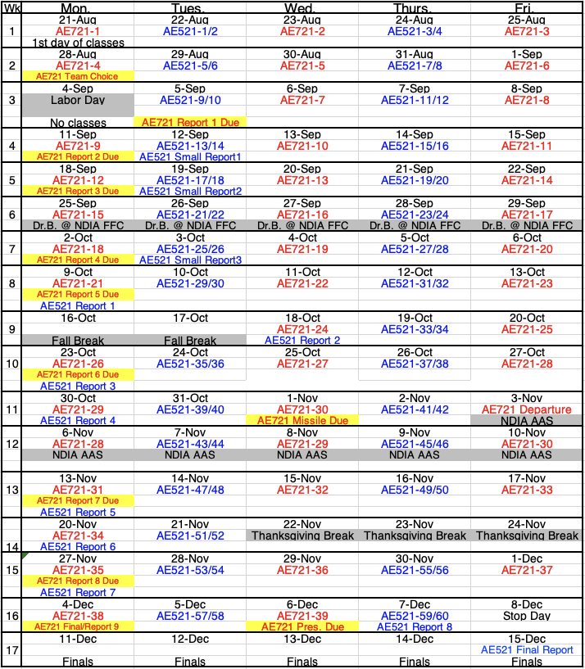
AE 721 Team Formation and Project Choice

Due Monday 28 August 2023, 12pm Noon

Due electronically to be sent to: kuaerodesign@gmail.com

Reading Assignment (for upcoming tests & quizzes): (for background information)

Schumacher, L. N., "The Development of Design Requirements and Application of Guided Hard-Launch Munitions on Aerial Platforms," MS Thesis 26 August 2016.

https://www.aerodoc.tech/bass

Total Points: -10 per day overdue

1. Decide on which topics you like the most and least and rank order them (1 least desirable, 10 most desirable):

___1.1 Ram Air Inflated Duct Eccentric Ramjet (RAIDER) AIM-120 AMRAAM Replacement
___1.2 RAIDER AIM-9 Sidewinder Replacement
___1.3 RAIDER Long-Range GMLRS Replacement
___1.4 RAIDER 155mm Boeing/Nammo Ramjet Artillery Shell Replacement
___1.5 RAIDER 105mm Boeing/Nammo Ramjet Artillery Shell Replacement
___1.6 BASS 155mm Indirect Fire Long-Range Hypersonic Air-Launched Artillery
___1.7 BASS 105mm Indirect Fire Long-Range Hypersonic Air-Launched Artillery
___1.8 BASS 30mm Hypersonic Direct Fire Air-to-Ground Aerial Gunnery Ammunition
___1.9 BASS .410 Ammunition Inert Components

2. List Preferred Teammates (up to 5)

2.1 ____________________________________________________________
2.2 ____________________________________________________________
2.3 ____________________________________________________________
2.4 ____________________________________________________________
2.5 ____________________________________________________________

