AE 521 Final Report Required Contents

Due Friday, 15 December 2023, 5pm to: kuaerodesign@gmail.com

Total Points: 50

Notes on Team Assignment:
Note that the work to be performed for this report is to be done by a team of students numbering up to 5 individuals.
AE521_Report12_TeamName.docx example: AE521_Report12_SkyHawks.docx
AE521_Report12_TeamName.pdf example: AE521_Report12_Skyhawks.pdf
Note that you must turn in docx, .pdf and coding files

What follows is a specification for the minimum required contents report. Your report must be organized in this manner. You may, within each section, add sub-sections if you so desire. Each chapter must start with a statement of purpose, except the Introduction and the Summary/Conclusions chapters.

Report Title: AE 521 Report 12 Final Report Preliminary Sizing Chart Generation

Cover - This is a good idea for both the .doc and .pdf files as it will be necessary when the file is printed to a hard copy. Name all team members.

Title Page - This page should be the first page of the report (if a cover is used, then it will be within the cover page).

Acknowledgments – Optional, make them real. Thank Mom/Dad/HS Teachers/Pets as you feel appropriate.

Table of Contents - The table of contents shall be structured as follows:

Table of Contents page
List of Symbols iii
Acknowledgment iv
1. Introduction 1
2. Chapter 2 Major Heading 3
2.1 Chapter 2 First Section 3
2.2 Chapter 2 Second Section 5
2.2.1 Chapter 2 First Subsection of Second Section 5
etc.

Page Numbering - The first section of the report containing the list of symbols, acknowledgment, list of tables and list of figures etc. shall be numbered with lower case Roman numerals. The body shall be numbered sequentially with Arabic numerals 1, 2, 3, etc. The Appendices shall be numbered with the letter of the appendix first followed by a dash and a page number: A-1, A-2, A-3; B-1, B-2, B-3 etc.

List of Symbols - You must include any symbols that are used in this report. You must give the names of the symbols and the units. After the main body of the symbols, you should include Greek symbols, then subscripts, followed by acronyms.

List of Symbols
Symbol Definition Units
c chord in
C integration constant lbf
mean geometric chord in
derivative of integration constant with takeoff weight ~
second derivative of chord with span 1/in
c_{l} section lift coefficient ~
C_{l} rolling moment coefficient ~
C_{L} airplane lift coefficient ~
c_{lα} section lift curve slope 1/rad
C_{Lα} airplane lift curve slope 1/rad
C_{n} yawing moment coefficient ~
C_{nβ} yawing moment coefficient with respect to sideslip 1/rad
L rolling moment ft-lbf
M Mach number, pitching moment ~, ft-lbf
N yawing moment ft-lbf
T thrust lbs
W weight lbs

etc.

Greek Symbols
α Angle of Attack deg. or rad.
β Sideslip angle deg. or rad.
etc.

Subscripts
δ_{f} Due to flap deflection ---
TO Takeoff ---
etc.

List of Figures - List any and all figures that are found in the report along with the page they are found on.

List of Tables - List any and all tables that are found in the report along with the page they are found on.

Notes on Generated Codes and Plots
Any suitable code may be used (like Excel, MatLab, other coding language). The original code must be turned in with the homework. If Matlab or another computational code is used to generate figures in the body, include the code in a separate appendix, one appendix for each code used. If Excel is used, then include screen shots. Note that both Matlab and Excel (and any other computational codes) must be submitted separately as well.

1. Introduction:
Choose a competition design to analyze the rest of the semester and possibly in the Spring. Describe why your team likes this design better than the others. If you choose a design of your own construction, tell the reader why you want to work on this particular kind of aircraft.

2. Abbreviated Operating Statement (AOS)
Generate an AOS for your team’s chosen design. Make it good and put some thought in it.

3. Concept of Operations (ConOps)
Generate a ConOps for your team’s chosen design as was covered in class. Show all principal mission phases and interactions

4. Mission Specification
Generate a Mission Specification for your team’s chosen design as was covered in class. Include all information in tabular form, taken straight from your chosen AIAA or VFS specification.

5. Mission Profile
Generate a Mission Profile for your team’s chosen design as was covered in class. Make SURE to do it in 3 dimensions with a CAD ribbon as was covered.

6. Objective Function (OF)
Following all of the steps presented in class, generate an objective function for your aircraft design. Include all requirements and objectives as well as at least five ancillary objectives. Define all terms, requirements and objectives and present a final mathematical expression for the objective function and all of its components.

7. Configuration Sweep
After examining the class notes and the chosen AOS, ConOps, Mission Specification, Mission Profile and OF, generate and CAD up no less than 10 more different configurations that may satisfy the spec beyond last week’s 5 (for a total of at least 15). Make 15 figures, one for each configuration like the one below discussing the pro’s and con’s of each design.
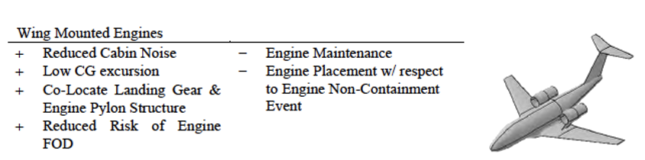

8. Application of Objective Function to Configuration Sweep and Downselection
Construct a table as shown below for all 15 configurations. Using reason and logic when possible, score each Objective and Ancillary Objective for each design. Using your Objective Function (OF) obtained in Chapter 6, score each design relative to the others. Using your OF, choose the top 3 configurations as the “downselected designs” and highlight them at the end of the chapter, explaining to the reader why they are considered superior.
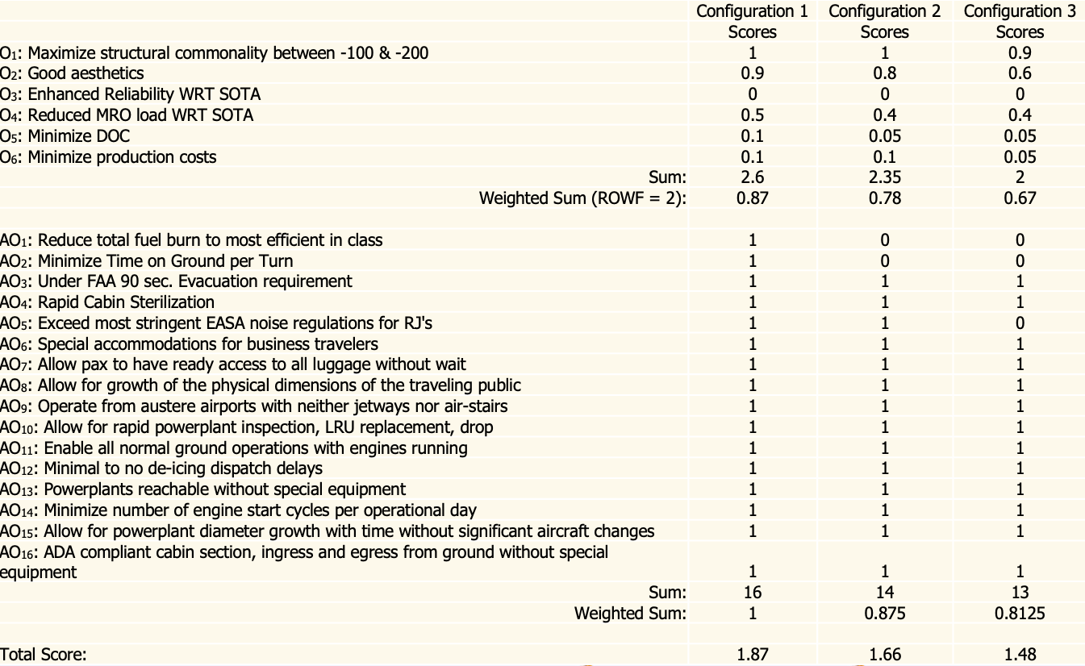

Chapter 9 Preliminary Weight Sizing

9.1 We/Wto Establishment via STAMPED Techniques
Considering the category of aircraft specified, survey at least a dozen aircraft to get empty weight to takeoff weight trending. For missiles, choose only air-to-air missiles (to make for a reasonable workload) and estimate rocket propellant using a density of 0.1lbm/cuin if the weight of the propellant cannot be found.

9.2 Estimate Aircraft Sizing Data
By examining historical information and your downselected configuration get estimates for L/D_{cr}, L/D_{ltr}, C_{p}, C_{j}, η_{p}. Tabulate the data listing the sources of the estimates.

9.3 Weight Sizing
By using the techniques spelled out in the class notes, applying the above estimates to the Mission Profile laid out in Chapter 2 estimate the aircraft weights: W_{to}, W_{e}, W_{f}, W_{oe}. Place detailed calculations in Appendix A.

9.4 Market Leader Performance Estimation (10 points extra credit)
Find the market leader from the survey information. Determine its design mission profile and assume reasonable values for L/D_{cr}, L/D_{ltr}, C_{p}, C_{j}, η_{p}. Then adjust those values, especially the L/D's and specific fuel consumptions till the solution converges on the published weights as was done in the course notes for the Skyblazer.

Chapter 10 Sizing Chart Construction, Design Point Selection and Thrust, Power and Wing Sizing
Begin the chapter with a short introductory paragraph -- just a sentence or two telling the reader what is to come.

10.1 Generation of Sizing Chart Constraint Lines
Following the procedures laid out in Dr. Roskam's Airplane Design Part I: Preliminary Sizing of Airplanes, and the course notes, generate the aircraft sizing chart given the constraints for your certification base, specification and type of aircraft. Include each of the sections below as appropriate:

- Stall Speed Constraints (if applicable)
- Takeoff Distance Constraints
- Landing Distance Constraints
- Drag Polar Estimation
- Climb Constraints
- Maneuvering Constraints
- Speed Constraints

For proper completion of this section you will be required to do at least one hand calculation for each step, showing all details in an appendix. If the appendix is over 5 pages, include a table of contents in the appendix. Note that students are required to plot all constraint lines individually for each subsection above.

All sizing charts must have hatch marks on the bounds indicating which side of the line flight is not sustainable given the pictured constraint. Olivia and Dr. B. are expecting Zooms, emails and/or phone calls. No problem -- if you're unsure, just get in touch.

10.2 Sizing Chart Assembly and Design Point Selection
Assemble all of the sizing lines above on one large sizing chart. This chart should be presented in landscape format. Include all of the proper axes and hatch marks as shown in Figures 3.34, 3.35 and 3.36 in Airplane Design Part I. Make sure to list a range of C_{Lmax} values for takeoff, landing and clean. Then select a design point for your upcoming aircraft. Note this design point selection explicitly with an easily seen symbol, arrow and label: "Design Point."

Given that design point, then list the following values numerically (off the chart on another page of your report):

W/S, W/P or T/W, C_{Lmax}, C_{Lmaxto}, C_{LmaxL}

Given your aircraft takeoff weight that you calculated in Chapter 9.3, List:

S, P_{to} or T_{to}, C_{Lmax}, C_{Lmaxto}, C_{LmaxL,} Missile competitors should list relevant thrust and wing area values.

These should form the core of your major conclusions and should be listed again in the following chapter as well. Show STAMPED time trends overlaid on your sizing charts as well.

11. Summary and Recommendations

11.1 Summary
Summarize the contents of the report in a few sentences or (better) bullet points that are properly introduced with a grammatically complete sentence. Speak particularly to the downselected designs and include their figures. Be sure to include all thrust, power, weights, areas, wing loading, power loading, thrust loading and any other important numbers here.

11.2 Recommendations
Make any real recommendations about the analysis techniques, future work to be done, etc.. You must include at least one recommendation. Be sure to start with a phrase like: “This author recommends that:” or similar.

References
As laid out in Report 1.

Appendices: Include as much information as the team deems relevant in one or more appendices. Make sure to include the appendix number and name in the Table of Contents, but not its page numbers. Note that appendices are stand-alone documents with page numbering like A-1, A-2, A-3… etc. Include a Table of Contents in the appendix if it is over 5 pages long. Include also symbols that are used in the appendices in a List of Symbols in the appendix if the number of pages is over 5 pages long.

