AE 721 Report 8 Required Contents

Due Monday 11 November 2024 9am
by e-mail to <kuaerodesign@gmail.com>
AE721_Report8_TeamProjectName.docx example: AE721_Report8_20mmBASS.docx
AE721_Report8_TeamProjectName.pdf example: AE721_Report8_20mmBASS.pdf
AE721_Report8_TeamProjectName.xslx (or other code extension)

Team Assignment
Note that the work to be performed for this report is to be done by a team of students.

Total Points: 50
What follows is a specification for the minimum required contents report. Your report must be organized in this manner. You may, within each section, add sub-sections if you so desire. Each chapter must start with a statement of purpose, except the Introduction and the Summary/Conclusions chapters.

Report Title: AE 721 Report 8 Proverse Engineering of Anti-Missile Missile & Build

Cover - This is a good idea for both the .doc and .pdf files as it will be necessary when the file is printed to a hard copy. Name all team members.

Title Page - This page should be the first page of the report (if a cover is used, then it will be within the cover page). This page should be numbered as page "i."

Acknowledgments – Optional, make them real. Thank Mom/Dad/HS Teachers/Pets as you feel appropriate.

Table of Contents - The table of contents shall be structured as follows:

Table of Contents page
List of Symbols iii
Acknowledgment iv
1. Introduction 1
2. Chapter 2 Major Heading 3
2.1 Chapter 2 First Section 3
2.2 Chapter 2 Second Section 5
2.2.1 Chapter 2 First Subsection of Second Section 5
etc.

Page Numbering - The first section of the report containing the list of symbols, acknowledgment, list of tables and list of figures etc. shall be numbered with lower case Roman numerals. The body shall be numbered sequentially with Arabic numerals 1, 2, 3, etc. The Appendices shall be numbered with the letter of the appendix first followed by a dash and a page number: A-1, A-2, A-3; B-1, B-2, B-3 etc.

List of Symbols - You must include any symbols that are used in this report. You must give the names of the symbols and the units. After the main body of the symbols, you should include Greek symbols, then subscripts, followed by acronyms.

List of Figures - List any and all figures that are found in the report along with the page they are found on.

List of Tables - List any and all tables that are found in the report along with the page they are found on.

Notes on Generated Codes and Plots
Any suitable code may be used (like Excel, MatLab, other coding language). The original code must be turned in with the homework.

Notes on Previous Work
Include write-ups and technical work from previous assignments. Correct any mistakes made in the new report to be turned in. Note that if an error is flagged in an earlier report and it is not corrected in a later report, twice the number of points will come off.

1. Introduction & Background Research on Benchmark Systems
Research your benchmark missile systems (Table 1 Below). Tell the reader in words what each of the benchmark system does, what its state of research or sales volumes and combat records have been like (if available). Look at Table 2 for more details on what to consider for this section.

Table 1 Team Chosen Missile Systems
Team 1 AIM-9/FIM-92 Interceptor
Team 2 Starstreak Interceptor
Team 3 MASS Interceptor
Team 4 Electric Missile Interceptor
Team 5 RAIDER Missile Interceptor
Team 6 COTS Interceptor

2. Benchmark Descriptions & Salient Characteristics

Research the benchmark systems below and list benchmark salient characteristics of the missile itself including all weights, volumes, warheads, propellents, etc. Also list the performance values for each system.

Table 2 Benchmark Interceptor Team Assignments
Interceptor Variant | Benchmark
Team 1 AIM-9/FIM-92 Interceptor | Using publicly available information, determine as much salient information as possible about the AIM-9 and FIM-92 families of missiles. Consider the most modern variants of the missiles.
Team 2 Starstreak Interceptor | Using publicly available information, determine as much salient information as possible about the AIM-9 and Starstreak families of missiles. Consider the most modern variants of the missiles.
Team 3 MASS Interceptor | Get information on air defense artillery guns that are capable of hitting targets as high as 30,000 ft. Investigate first the German 88mm FlaK guns. List the salient characteristics of the guns and ammo.
Team 4 Electric Missile Interceptor | Read 40mm Valkyrie report and list the salient characteristics of the aircraft. Find salient characteristics of the several variants of the Aerovironment Switchblade drones.
Team 5 RAIDER Missile Interceptor | Examine last year’s RAIDER AIM-9 and RAIDER AIM-120 reports and list the salient characteristics of each missile. Also list the salient characteristics of more modern AIM-9 and AIM-120 missiles.
Team 6 COTS Interceptor | Find as much information as possible describing the COTS 4” dia. Model AMRAAM AIM-120C. Find as much information about the AIM-120C as possible as well. List the salient characteristics of both.

3. Benchmark Round Performance L/D Determination
For the chosen round family, determine and list its performance numbers. For the following, get all relevant geometries listed in Fleeman to estimate aerodynamic characteristics (lengths, diameters, nose geometries fin spans etc.). Stick as faithfully to the benchmark rounds listed below, adjusting and interpolating for size as needed.

Table 3 Interceptor Team Assignments
Interceptor Variant | Benchmark
Team 1 AIM-9/FIM-92 Interceptor | Using the information in Chapter 2 and the class notes, reverse engineer modern AIM-9 family members and FIM-92 family L/Dcruise values.
Team 2 Starstreak Interceptor | Using the information in Chapter 2 and the class notes, reverse engineer modern AIM-9 family members and Starstreak family L/Dcruise values.
Team 3 MASS Interceptor | Enter each benchmark round found in Chapter 2 in your ballistics code and verify the performance of the system. Provide a plot showing altitude with range at the prescribed muzzle velocity.
Team 4 Electric Missile Interceptor | Read 40mm Valkyrie report and determine the design L/Dcruise value for the RAIDER and if possible, the Switchblade family of munitions.
Team 5 RAIDER Missile Interceptor | Using the information in Chapter 2 and the class notes, reverse engineer modern AIM-9 family members and AIM-120 family L/Dcruise values.
Team 6 COTS Interceptor | Using the information in Chapter 2 and the class notes, reverse engineer modern AIM-120 family L/Dcruise values.

5. Proverse Missile Design Code Generation
Using the methods outlined in class, make a code (Matlab, Excel or other) so as to predict the flight of an AMRAAM missile launched from sea level from a saboted tube at 300 m/s at a 45 deg. angle. Determine and graph all of the important characteristics of the flight including distance, altitude, total speed, Mach no., elapsed time and L/D experienced in flight. Trim the aircraft so as to maintain a 45 deg. flight path angle for as long as possible (knowing that after burnout there will be a glide, then fall to earth). Plot all variables with respect to distance on the horizontal axis in meters.

If any variable is missing or you are uncertain, make a reasonable assumption, state that assumption and Move On.

6. Proverse Missile Design
Using the methods outlined in class, proverse engineer your Anti-Missile Missile. Get as close as possible to your original configuration set that you assumed (fins, wings, canards, etc.). Include a CAD of your properly sized missile and booster. Include also a CAD with dimensions of your missile which you will actually build. Bear in mind that this will involve “shopping” online for properly sized components, so be careful what you spec. for your design. Include a Bill of Materials with all URLs and costs:

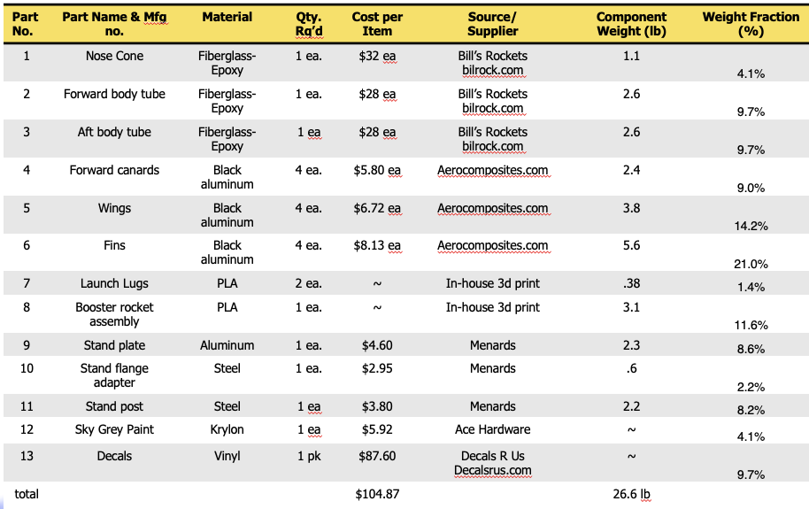
7. Build Update
Give the reader the status update of the components shown in the BOM of Chapter 6. Describe those components that are ordered, which have arrived, which are being cut, machined, 3-d printed or otherwise fabricated. If any components have been built or assembled, include photos. Describe assessment of specimen completion by 11/14 along with the carrying case or box.

8. New Design Performance Determination using Fleeman
For the chosen round, determine and list its performance numbers. For the following, get all relevant geometries listed in Fleeman or Roskam to estimate aerodynamic characteristics (lengths, diameters, nose geometries fin spans etc.). Proverse engineer your scaled interceptor with a higher level of fidelity by using the techniques laid out in Fleeman. Team 3 should model the flechette (not the sabot). Team 4 should model the electric missile using Roskam Part I for aerodynamic properties. All other teams should follow Fleeman

Table 8 Interceptor Team Assignments
Interceptor Variant | Modeling Methods
Team 1 AIM-9/FIM-92 Interceptor | Fleeman
Team 2 Starstreak Interceptor | Fleeman
Team 3 MASS Interceptor | Fleeman
Team 4 Electric Missile Interceptor | Roskam & Barrett
Team 5 RAIDER Missile Interceptor | Fleeman
Team 6 COTS Interceptor | Fleeman

8.1 Relate D/CD with Dynamic Pressure
Examine Fig. 2.2 in Fleeman. Regenerate this figure using the equation shown and present the results. Assuming C_{D} for your round is 0.45, plot Drag generated at Mach 1.5, 2, and 3 for your round at SL, 10,000 ft, 20,000 ft, 30,000 ft in a standard atmosphere. Team 4 will use Class I techniques of Roskam Part I.

8.2 Relate Body First Bending Mode Frequency
Examine Fig. 2.4 in Fleeman. Regenerate this figure using the equation shown and present the results. Make a reasonable assumption for the wall thicknesses and material types used.

8.3 Relate C_{Do} of the Body
Examine Fig. 2.7 in Fleeman. Team 4 will get an exact wetted area of the fuselage, then follow Roskam Eq. 3.21, Part I to determine C_{Dobody}. All teams, save Team 4, gegenerate Fig. 2.7 figure using the equation shown and present the results. Note that subsonic, transonic and supersonic Mach ranges are needed in both the coast and power conditions. For this figure, make the same assumptions as Fleeman.

8.4 Relate C_{Dobodywave} of the Benchmark Missile
Examine Fig. 2.8 in Fleeman. Regenerate this figure using the equation shown and present the results. Note that only supersonic Mach range is needed. For this figure, sweep through the same nose fineness ratios as Fleeman: 0.5, 1, 2, 5. Team 4 should explain to the reader that the principal wave drag will come from transonic effects on the propeller and follow sections in Schueler’s Reno Air Racer report for guidance.
Regenerate this figure, showing the results for your baseline weapon system. For Boeing/NAMMO projectiles, assume a tangent ogive of the same form factor.

8.5 Determine Boattail Effect
Examine Fig. 2.10 and 2.11 in Fleeman. Measure the amount of boattail on your reference munition. Using Fig. 2.11 as guidance, plot your estimated C_{Do} trend assuming the nose section is a 3 caliber tangent ogive (as shown in Fleeman). Using the relationships shown in Section 8.4 above, adjust the C_{Do} trend to match the type of nose of your benchmark round.

8.6 Relate Body Normal Force Coefficient to Aspect Ratio
Examine Fig. 2.12 in Fleeman. Regenerate this chart using aspect ratios of 1, 2, and 3.

8.7 Relate Body Lift-to-Drag Ratio with Aspect Ratio, Fineness Ratio and Angle of Attack
Examine Fig. 2.13 in Fleeman. Regenerate this chart using the four conditions listed, to arrive at the same trendlines he shows. Using your benchmark munition, plot its L/D trend on the same chart.

8.8 Relate Body Lift-to-Drag Ratio with Dynamic Pressure
Examine Fig. 2.14 in Fleeman. Regenerate this chart using the two assumptions of aspect ratios of 1 and 2. Assuming that ½ of your fuel is consumed in your baseline munition (thereby emulating mid-course weight):
- Determine and plot the lift coefficient, C_{L} required to stay airborne at Mach 1.5, 2, 3, and 4 at altitudes of SL, 10,000 ft, 20,000 ft and 30,000 ft. Plot CL on the vertical axis, Mach number on the horizontal axis and four altitudes lines on this plot.
- Assume that the angle of attack will be small (<15°), therefore C_{N} ~ C_{L}. Use the relations determined to generate Fig. 2.12 to solve for angle of attack required for sustained, 1-g flight. Plot α on the vertical axis, Mach number on the horizontal axis and four altitudes lines on this plot, assuming a ½ fuel load.

- Assume that the angle of attack will be small (<15°), therefore C_{N} ~ C_{L}. Use the relations determined to generate Fig. 2.13 to solve for L/D for sustained, 1-g flight. Plot L/D on the vertical axis, Mach number on the horizontal axis and four altitudes lines on this plot, assuming a ½ fuel load.

8.9 L/D Comparisons
Examine Fig. 2.15 in Fleeman. Determine the planform area/body volume^(2/3) for your baseline weapon. Scan Fig. 2.15 and place the best L/D number of your baseline weapon on that chart. Contemplate the L/D figures that you arrived at for your baseline weapon system and the terrible L/D that will be achieved from a climbing intercept flight.

9. Body Aerodynamic Center Prediction
Read Section 2.10 and examine Fig. 2.18 in Fleeman. Regenerate this figure using the equation shown and present the results. Make the same assumptions as made by Fleeman. Then determine your baseline munition’s geometric parameters needed to find the aerodynamic center. Plot your baseline missile’s a.c. location trend with alpha on top of Figure 2.18.

10. Conclusions and Recommendations
10.1 Conclusions
Draw conclusions about your baseline weapon system’s overall performance, lift-to-drag ratio. Include information from all sections in this document including the ones from previous homework assignments.

10.2 Recommendations
Make any real (emphasis added) recommendations about the benchmark weapon system, analysis or modifications that could be made.

11. References
As laid out in Report 1.

Appendix A Effort and Section Reporting:
Because there have been multiple reports of serious slacking, this assignment will contain individual contribution section and individual peer grades. The contributions of each team member will be listed in this section like:

Place the % contribution for each teammate in the table below:
Teammate Name | Front | Formatting | Ch. 1 | Ch. 2 | Ch. 3 | Ch. 4 | Ch. 5 | Ch. 6 | Ref. | App.B | App.C | Etc. | Other
In addition to filling out the above table, students must fill out the peer grading form and submit it as well. Students will be given the raw report grade as before, then their grade will be decremented as recommended by an average of their peers. Note that this can go as far down as a score of 0 points for a given assignment, while the rest of the team scores between 60 and 100%. If reports of slacking persist, the next assignment will be individual.

Appendices B and on: Include as much information as the team deems relevant in one or more appendices. Make sure to include the appendix number and name in the Table of Contents, but not its page numbers. Note that appendices are stand-alone documents with page numbering like A-1, A-2, A-3… etc. Include a Table of Contents in the appendix if it is over 5 pages long. Include also symbols that are used in the appendices in a List of Symbols in the appendix if the number of pages is over 5 pages long.

Nota Bene: If Matlab or another computational code is used to generate figures in the body, include the code in a separate appendix, one appendix for each code used. If Excel is used, then include screen shots. Note that both Matlab and Excel (and any other computational codes) must be submitted separately as well.

