ME 492

Fundamentals of Competitive Aircraft Design

Course Outline and Requirements
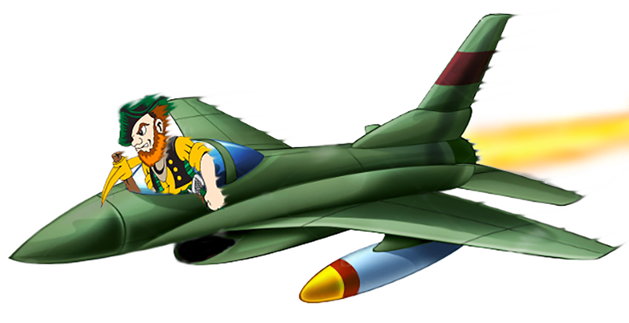

Spring 2026

1. General Items

1.1. Instructor and Contact Information:
Dr. Ron Barrett
adaptivebarrett@gmail.com, (785) 760-4614 (cell)
Physical Office Hours: TBD
GTA: None
Emergencies: Dial 911
Turn in all assignments to: kuaerodesign@gmail.com
Class Website: https://www.aerodoc.tech/me492

Let Dr. Barrett know what name you prefer him to call you, how to pronounce it and if you are comfortable. Dr. Barrett will make every effort (and practice) to get the pronunciation of your name absolutely right. Let Dr. Barrett know, privately or thorough proper KU channels if you need an accommodation of any kind.

Note that Dr. Barrett prefers to be called “Dr. B.”

Special Considerations Relating to COVID-19 and other pathogens: Follow CDC guidelines.

1.2 Course Description:
Catalog Description: Preliminary design project of a complete aircraft system. Technical written reports and oral presentations.

1.2.1. Prerequisites:
One or more controls, structures and powerplants courses.

1.2.2. Corequisite: None

1.3. Class and Lab Times and Locations:
Physical Class Location: C/M 266
Physical Class Times: 2 – 2:50pm MWF

1.4 Number of Credit Hours: 3

1.5 Required Texts, Membership and Instructional Materials

Roskam, J., "Airplane Design Parts I – VIII," published by DAR Corporation, Lawrence, Kansas 66047. https://www.darcorp.com

Students are asked to note that this set of books is considered very important for most aerospace design engineers and available in hard copy form and in Kindle form for just $10 each. Much of the course will be taught between volumes I – V, with VI – VIII being used as reference. The entire hard copy set retails for $295 at DARCorp.com If students can afford the hard copy, it is recommended; otherwise the Kindle version of I – V will suffice for most efforts.

If students choose the team missile design competition, the following book is recommended:

“Missile Design and System Engineering,” by Eugene L. Fleeman, 2022.
https://arc.aiaa.org/doi/book/10.2514/4.869082

All Competitive Aircraft Design students will compete in a competition sponsored by the American Institute of Aeronautics and Astronautics (AIAA). As such, all students will be required to get student membership (a requirement for competition). At last check, it was $37/yr:
https://aiaa.org/membership/types-of-membership/university-student-membership

1.6 Course Requirements/List of extracurricular activities, exams, quizzes, assignments, simulation activities, clinical encounters, community engagement and field trips
There are no currently scheduled extracurricular activities, exams, quizzes or other activities. This may change as the semester progresses at the discretion of the instructor for extra credit.

1.7 Course Learning Outcomes
Course Objectives: To allow a relatively large team of undergraduate students to design an aircraft in a multi-disciplinary team environment, report on the team results and submit this report in one of the undergraduate international AIAA team aircraft design competitions.
    - Design an airplane configuration to a given mission specification
    - Perform trade studies as part of design decision making
    - Carry out systems engineering, layout designs and system conflict analyses
    - Layout a preliminary structural arrangement accounting for manufacturing and assembly breakdown requirements
    - Predict the development cost, manufacturing cost, operating cost of airplanes
    - Understand the effect of economic, societal, environmental and political factors involved in airplane design decision making
    - Understand the role of ethics in design decision making
    - Understand the role of civil and military airworthiness requirements
    - Understand what it takes to work in small multi-disciplinary teams
    - Write a report or memo describing the results of work performed and learn to give oral briefings to industry experts for critical assessments
    - Analyze critical assessments from experts

1.8 Course Format and Teaching Methods
The course will be taught mostly in person with live lectures. Special circumstances may require the course be temporarily taught virtually (as during inclement weather or other emergencies). Notice will be given to students as quickly as possible during such occurrences. Given that Dr. Barrett is on sabbatical, a number of courses will be taught by pre-recorded videos.

1.9 Attendance: Physical attendance is not required.

1.10 Competition, Course Team or Individual Options
Students may opt to engage in the competitive design process individually or as part of a team endeavor. In any case, students MUST choose one of the two options below:
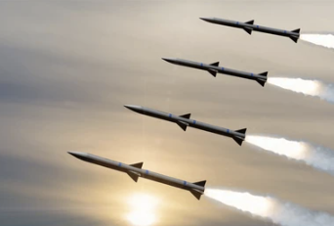
1.10.1 Aerospace Design Team Competition
Students may form teams of up to 10 individuals and participate in:
2025 – 2026 Missile Systems Design Competition High-Volume, Low-Cost Cruise Missile
https://aiaa.org/get-involved/university-students/design-competitions/#design-competition-rfps
Check the AIAA website for the latest updates
• Mach 3+ • 500 nmi • 2,000lb • GMLRS Launchers 18 x 18 x 154”

This option is for students who work well as a team. Note that there is much more work required for this option as up to 10 students can participate. Three team presentations are required in addition to the additional technical work. If infighting or slacking occurs, note that 200/1000 points is devoted to peer grades, so peers can take individual students down by up to 2 letter grades if the team wills such a dynamic. Dr. Barrett reserves the right to rescue individuals from a failing grade. Other than that, student peer grades typically hold, so choose team mates wisely.

1.10.2 Aerospace Design Individual Competition
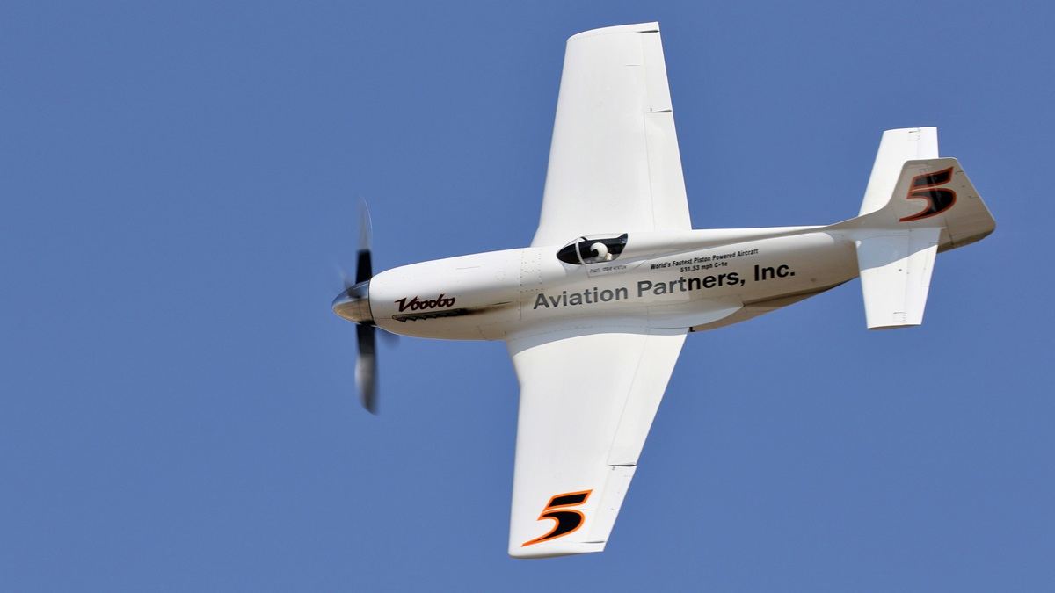
Individual students can participate in:
2025 – 2026 Undergraduate Individual Aircraft Design Competition: Unlimited Class Air Racer
Check the AIAA website for the latest updates
https://aiaa.org/get-involved/university-students/design-competitions/#design-competition-rfps
• 350+mph • 8 laps (52mi) • 4,000ft runway • 6+g’s

This option is good for students who don’t want to mess with team dynamics and yet are highly competitive and internally motivated. The workload is up to you in many ways – If you want to have a shot at a prize, work hard. You could be the first SDSMT student to win an AIAA Aircraft Design award! Note that your workload will be high, but the constraints associated with the team missile design including the presentations do not exist.

1.11 Course Grade
Students’ numerical course grades are the sum of various scores. The course grades will be determined from the following scale, using fractional grading (+/- letter grades):

Point Score: 950 900 850 800 750 700 650 <600
Course Grade: A A- | B+ B B- | C+ C C- | D+ D D- | F

1.11.1. Late Penalties:
A student who submits an assignment after the due date and time must have a valid excuse (medical/emergency) to receive full credit. If no valid excuse is given, the following penalties will be applied:
Late from 0 to 10 minutes: no points deducted
Late 10 minutes to 60 minutes: 1% of assignment per minute
Late from 1 hour to 24 hours: 50%
Late 24 hours to the end of the semester: 100%
Note that the time stamp on the SDSMT and other computer systems shall count as demonstration of the day and time when submission was made. Take note that many computer and e-mail systems tend to choke at due dates and times. Accordingly, procrastination is not advisable as no allowance will be made for "slow" e-mail systems/servers/computers.

Table 1 Point Distribution (Team)
Report 1 Mission Spec. & Profile, Historical Review | 20
Report 2 Design Optimization Functions, STAMPED & AIAA Membership | 20
Report 3 Wing and Powerplant Sizing | 30
Report 4 Cockpit and Fuselage Layout, Engine Installations & AIAA Letter of Intent | 30
Report 5 Wing Layout and High Lift Device Sizing & PDR | 30
Report 6 Empennage and Landing Gear Designs, Weight & Balance | 30
Report 7 V-n Diagrams, Payload-Range Diagrams, Configuration Sel. | 30
Report 8 Weight and Balance Analysis, Class I System Layout, S&C | 30
Report 9 Class II Landing Gear Sizing, Compliance Matrix | 40
Report 10 Class II Systems Layout | 40
Report 11 Class II Design CAD, Exploded Views | 40
Report 12 Situational Rendering | 40
Report 13 Class II Structural Layout | 40
Report 14 Class II Stability and Control & Cost Analysis | 60
Preliminary Design Review (PDR) | 20
Critical Design Review (CDR) | 40
Final Design Review (FDR) | 60
Peer Grade | 200
Report Submission | 200
Total: | 1000

Table 2 Point Distribution (Individual Active Competition)
Report 1 Mission Spec. & Profile, Historical Review | 20
Report 2 Design Optimization Functions, STAMPED & AIAA Membership | 30
Report 3 Wing and Powerplant Sizing | 30
Report 4 Cockpit and Fuselage Layout, Engine Installations & AIAA Letter of Intent | 40
Report 5 Wing Layout and High Lift Device Sizing & PDR | 40
Report 6 Empennage and Landing Gear Designs, Weight & Balance | 40
Report 7 V-n Diagrams, Payload-Range Diagrams, Configuration Sel. | 50
Report 8 Weight and Balance Analysis, Class I System Layout, S&C | 50
Report 9 Class II Landing Gear Sizing, Compliance Matrix | 50
Report 10 Class II Systems Layout | 60
Report 11 Class II Design CAD, Exploded Views | 60
Report 12 Situational Rendering | 60
Report 13 Class II Structural Layout | 80
Report 14 Class II Stability and Control & Cost Analysis | 90
Report Submission | 300
Total: | 1000

1.11.2 Quizzes
No quizzes or tests will be administered for the duration of the class for regular credit.

1.11.3 Reports
Reports are due on Mondays by 8am Mountain Time and turned in to: kuaerodesign@gmail.com

Reports and Excel files must be named as follows:
ME492_Report#_Teamname.doc example: ME492_Report1_Zappers.doc
ME492_Report#_Teamname.pdf example: ME492_Report1_Zappers.pdf
ME492_Report#_Individual’s Last Name.doc example: ME492_Report1_Barrett.doc
ME492_Report#_ Individual’s Last Name.pdf example: ME492_Report1_Barrett.pdf
ME492_Report#_ Individual’s Last Name.xlsx example: ME492_Report1_Barrett.xlsx

Students must submit their original .doc file (or file from the package that generated the document) along with a .pdf version of the report. The .pdf documents will be graded in detail. The .doc files will be used for plagiarism checking.

1.11.3.1 Submitted Report File Sizes
Each report must be under 10MB in file size. For each 100k of extra file size beyond the limits above, a penalty of 1% of the report value will be assessed. The limit of this penalty shall be 40% of the report value. The size of the file received by the GTA and Dr. Barrett shall be the size of the file used for this assessment, NOT the size of the file sent. So check your file size by performing a test send to yourself.

1.11.3.2 Each report must meet the minimum standards of professionalism. Unprofessional reports will be severely downgraded even if the technical contents are correct. Follow AE 521 Guidelines for guidance.

Have a second pair of eyes go over your reports. Asking a classmate who is technically skilled is a good choice as they can catch many technical things. Asking someone outside of engineering to do this is also good as well as they can catch spelling, diction & grammar errors.
You will have multiple opportunities to provide feedback on your experience in this course. Suggestions and constructive criticism are encouraged throughout the course and may be particularly valuable early in the semester. To that end, I will use mid-semester surveys and/or reflection assignments to gather input on what is working well and what could be improved. You will also be asked to complete an end-of-semester, online Student Survey of Teaching, which could inform modifications to this course (and other courses that I teach) in the future.

1.12 Assignments and Examinations

Table 3 ME 492 Due Dates and Schedule
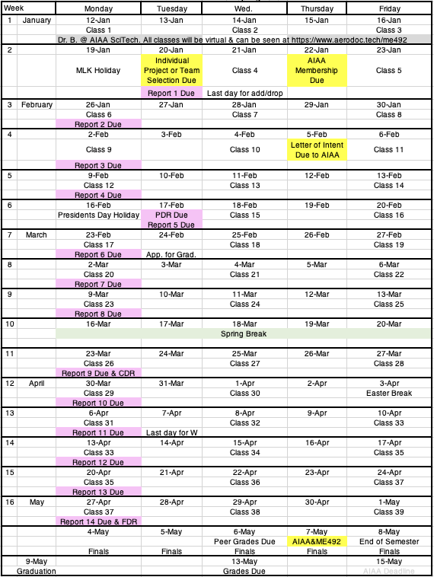

1.13 Classroom Behavioral Expectations
Students are expected to behave professionally, obey all Federal, State and Local laws at all times and be kind to all in the classroom. Failure to do so may result in ejection from the classroom. Spirited debate is expected and encouraged so long as the demeanor and discourse are kept on a professional level.

1.14 This Document Subject to Change!

Check

https://www.aerodoc.tech/me492

daily for updates.

2. Course Topics and Structure
The class will cover the following topics in Roskam’s Airplane Design series and in Fleeman’s Missile Design books. The following topics will be covered:

Table 4 Topics and Lecture Periods
1: Mission Specification and Profile, Measures of Merit
2: Overview of Related designs and STAMPED vector Input
3: STAMPED Vector Analysis, Design Philosophy Establishment and Application to specific aircraft design
4: Class I STAMPED Vector Weight Sizing
5: Class I STAMPED Vector Wing and Powerplant Sizing
6: Overall Configuration Selection, Class I Configuration Fly-offs
7: Class I&II Cockpit & Fuselage Layout
8: Class I&II Propulsion System Layout and Integration
9: Class I&II Wing & High Lift Layout via STAMPED Vector Carpet Plots
10: Class I&II Empennage Sizing via STAMPED Vector Analysis
11: Class I&II Undercarriage Integration
12: Class I&II Weight and Balance Analysis
13: Class I&II Stability and Control
14: Class I&II Drag Build-Ups & Drag Polars
15: Class I&II Propulsion Performance
16: Performance Verification, Fly-off and Comparisons
17: Systems and Subsystems Layout
18: Structures, Manufacturing Breakdown & Fabrication/ Production Flow, disposal
19: Advanced Technologies
20 Cost Estimation
21 Life Cycle Impacts
22 Salient Characteristics and Final Three-View

3. ME 492 Team Formation and Project Choice

Due Monday 20 January 2026, 8am

Due electronically to be sent to: kuaerodesign@gmail.com
Name: __________________________________________

Reading Assignment (for background information)

https://www.aiaa.org/get-involved/students-educators/Design-Competitions

Total Points: -10 per day overdue

1. Decide on which topics you like the most and least and rank order them (1 least desirable, 10 most desirable):

___1.1 AIAA Team Missile Design

___1.2 AIAA Individual Unlimited Class Racer

2. List Preferred Teammates (up to 9), Identify Preferred Team Leader (if team chosen)

2.1 ____________________________________________________________
2.2 ____________________________________________________________
2.3 ____________________________________________________________
2.4 ____________________________________________________________
2.5 ____________________________________________________________
2.6 ___________________________________________________________
2.7 ___________________________________________________________
2.8 ___________________________________________________________
2.9 ___________________________________________________________

